CTL DECISION SHEET (DSH)

Standard(s) (incl. year) | Subclause(s) | No. | Year
IEC 60950-1:2005 2nd ed. | 2.9 / 2.10.1 / 5.3.4 | DSH 798 | 2011
Category | 2.9 / 2.10.1 / 5.3.4 | DSH 798 | 2011
OFF | 2.9 / 2.10.1 / 5.3.4 | DSH 798 | 2011
Subject | Keywords | Developed by | Approved at
Insulation requirement from mains input (between L and N) up to the fuse |  | ETF2 | 2012 CTL Plenary Meeting
Question
Which insulation requirement is demanded from the mains input up to the equipment fuse?

Decision
Functional insulation is sufficient.

Explanatory notes
Argumentations are as following:

1.
According to clause 2.9 functional insulation (F6) is required between primary circuits. Reason: See below part of figure 2F:

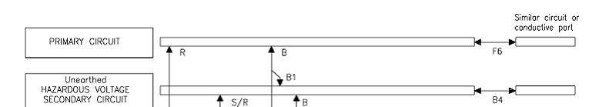

2.
For functional insulation creepage and clearance distances smaller than those specified in clause 2.10 are permitted. Reason: Clause 2.10.1 states:
3.
Clause 5.3.4b) states

5.3.4 Functional insulation
For FUNCTIONAL INSULATION, CLEARANCES and CREEPAGE DISTANCES shall satisfy one of the following requirements a) or b) or c).

4.
If the equipment under test withstands the electric strength test as demanded in 5.3.4 b) the requirement for functional insulation is kept even if the spacing as demanded in 2.10 is not kept.

